Name __________________________________________ Period ____________ Class ___________
Appendages of the Skin
The appendages of the skin – hair, nails, and cutaneous glands – all derive from the epidermis, but they reside in the dermis. They originate from the stratum basale and grow downward into the deeper skin regions.
Activity 1: Skin Model, Revisited

Locate the following structures on the skin model (refer to p. 112-113 in your book). Write the name of the structure next to its corresponding letter or number below.

Apocrine duct
Apocrine sweat gland
Arrector pili
Eccrine duct
Eccrine sweat gland
Hair
Hair follicle
Hair root
Sebaceous gland

1a: Eccrine sweat gland
1b: Eccrine duct
2a: Apocrine sweat gland
2b: Apocrine duct
4: Hair
5: Hair root
6: Hair follicle
7: Sebaceous gland
8: Arrector pili

Using the structures you identified above, describe at least three differences among the skin types displayed on the model (scalp, axilla / armpit, and sole of the foot). Only the axilla (armpit) contains apocrine sweat glands & their ducts; The scalp has the most hair, the axilla (armpit) has some hair, and the sole of the foot has no hair; Only areas with hair (see above) have the associated structures: hair follicles, sebaceous glands, and arrector pili.

Activity 2: Plotting the Distribution of Sweat Glands
Which skin area tested has the most sweat glands? Why do you think this is so? The palm has a greater density of sweat glands than the arm, perhaps because it is hairless and can better cool the skin?
List some of the components of sweat: Sweat contains primarily water, plus some salts (sodium chloride), vitamin C, traces of metabolic wastes (ammonia, urea, uric acid), and lactic acid.
What type of sweat glands did you examine in this investigation? Eccrine sweat glands
Name the other type of sweat glands and describe their location. The other type are apocrine sweat glands, which are only found in the armpits and genital regions.
Are sweat glands endocrine or exocrine glands? In your answer, describe the difference between the two. Sweat glands are exocrine glands. Endocrine glands, like the thyroid, adrenal, and pituitary glands, release their secretions (hormones) directly into the blood. Endocrine glands do not have ducts. Exocrine glands, like the cutaneoud glands, liver, and pancreas, release their secretions into ducts that lead to an epithelial surface.
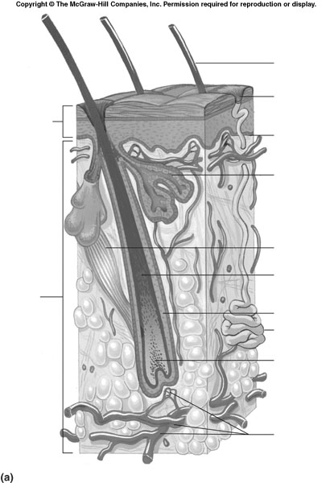
Activity 3: Hair
Label each structure listed below in the hair diagram to the right (use p. 118).
hair shaft

- Adipose tissue
sebaceous gland
- Arrector pili muscle
- Hair follicle
- Hair root
arrector pili
- Hair shaft
hair root
- Matrix (growth zone)
hair follicle
- Sebaceous gland
Is the hair follicle composed of epidermal tissue, dermal tissue, or both? Both
matrix
Which two specific types of glands empty into a hair follicle? Sebaceous glands and apocrine sweat glands
adipose tissue

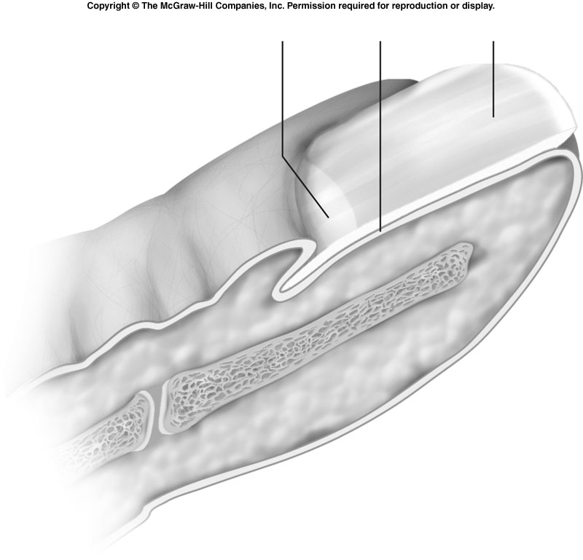
Activity 4: Nails
body of nail
lunula
- Examine your own fingernail with a hand lens. Identify the body of nail, lunula, and cuticle.
cuticle
- Label each structure listed below in the nail diagram (use p. 120). You may need to draw your own lines.

- Body of nail
nail matrix
- Cuticle
- Lunula
- Nail matrix (growth zone)

Describe two similarities between hair and nails. Both are made of dead, keratinized cells; both are produced by the stratum basale of the epidermis; both grow from an area called the matrix.

Activity 5: Burns
After reading the section about burns on pp. 121-123, answer the following questions:
Why is dehydration an issue for burn victims? Explain. The body loses fluids as they seep from the burned surfaces.
What is the leading cause of death in burn victims? Infection
For each type of burn, describe the damage to the skin (be specific!), treatment, and prognosis:
- First-degree burn: Only the epidermis is damaged, becoming red & swollen; no special treatment necessary; heal in 2-3 days.
- Second-degree burn: Damage to the epidermis and upper layer of the dermis, with pain, redness, and blisters; treatment involves preventing infection; full regeneration will occur with minimal scarring.
- Third-degree burn: Destroy the entire thickness of the skin, including the nerve endings (which makes them painless), and the skin appears gray-white or blackened; regeneration is not possible, so treatment involves skin grafting; 3rd degree burns may be critical, depending on the size and location of the areas burned.

